Lab 4 – Recon-ng

1. free tier key doesn’t work  
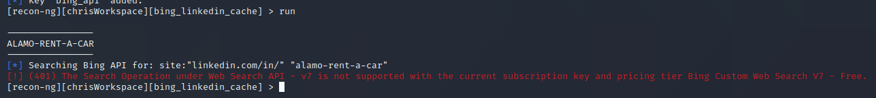  
I confirmed that it wasn’t due to a typo in the key, as this message presents when the key is broken  


2. the whois_miner is broken.  
 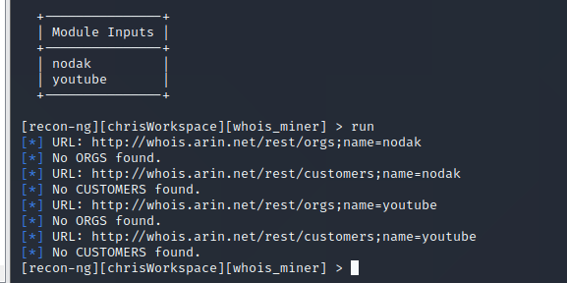  
whois returns a search for “nodak”:

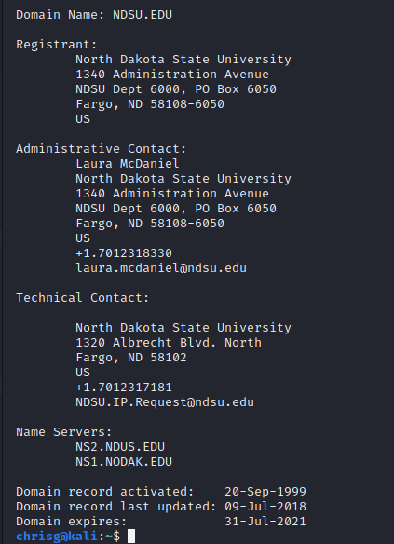

whois.arin.net returns NDSU when searching nodak:

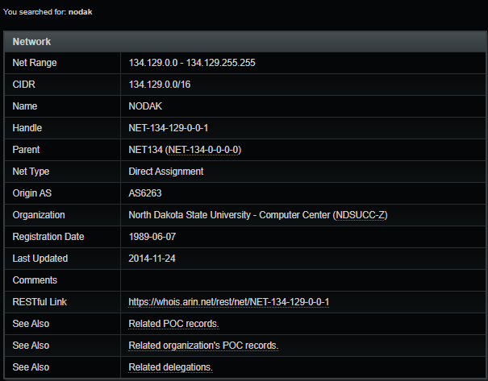  
Note: I also tried using “ndsu” “north dakota state university” “ndsu.edu” “NDSU” etc. then I just stuck youtube in there to see if it was working… I do have internet connection, tested that to make sure It wasn’t just failing to get out. The links provided by the url scheme that the program uses to search are dead links… I suspect the url scheme has been updated since this module’s last update (I confirmed that I am up to date)… I don’t believe the intent of this assignment was to refactor the source of the modules, so I am moving on.

3. hibp_breach is also broken (payed for the key, too)  
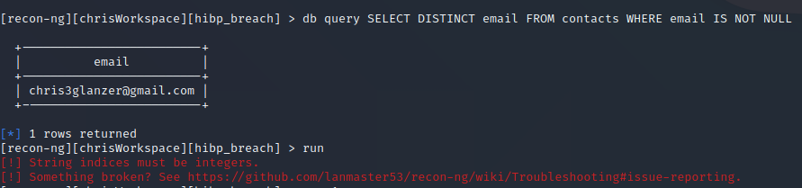

4. bing api key still doesn’t work



5. this module isn’t feeding me anything, but no errors either. The ping in the screencap is to prove that I actually have an internet connection.  
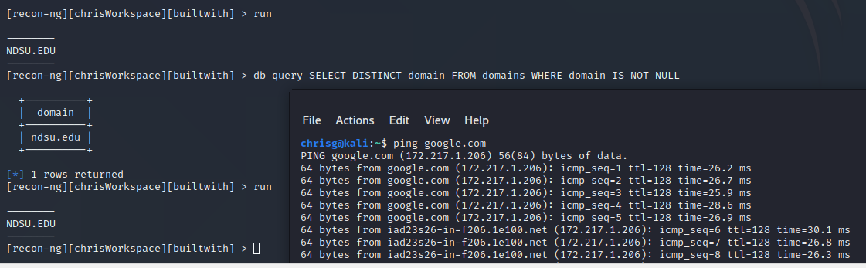

7. Sign up for flickr API: <https://www.flickr.com/services/api/misc.api_keys.html> Perform search to show images within 1 km of the DSU campus. (Hint: Use Google to find longitude and latitude coordinates.)

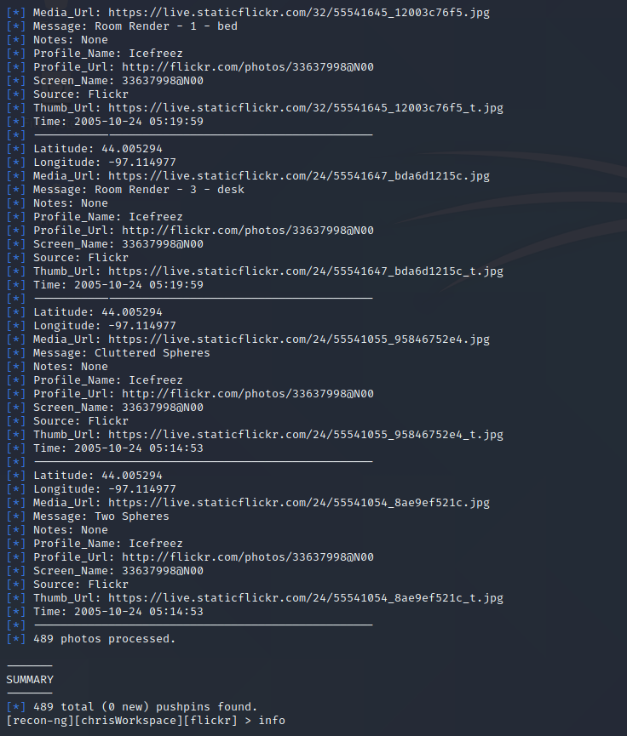

8. Use one other module of your choice in recon-ng to perform a search on a specific site/person/place/entity.

I opted to use the pushpins reporting module to view the info we just pulled from flickr. It ran, and flickr didn’t have any issue taking the info. When we moved into gmaps, though the map flashed with the pins before throwing an error.  
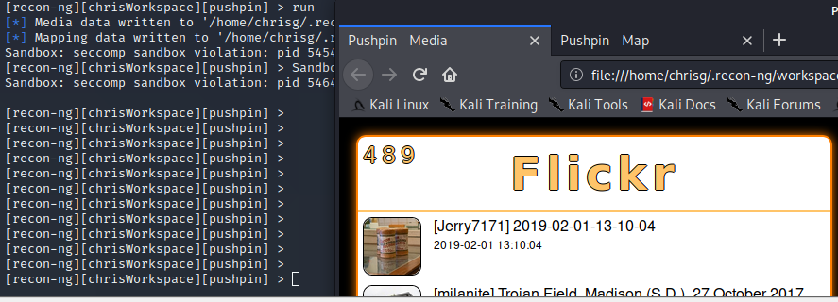  
gif of the maps issue: <https://gyazo.com/8b5e98cf36abed9129f173ffa881c7ae>

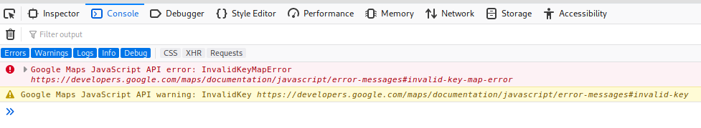

We get a pretty good idea of what it should look like. This requires jumping through loops to get a google api key so… :/

**Deliverables**

These MUST be contained all in one PDF or DOC/DOCX.

You may select **two questions** to skip if you so desire.